Inferential Statistics
Second\Discrete Probabilities
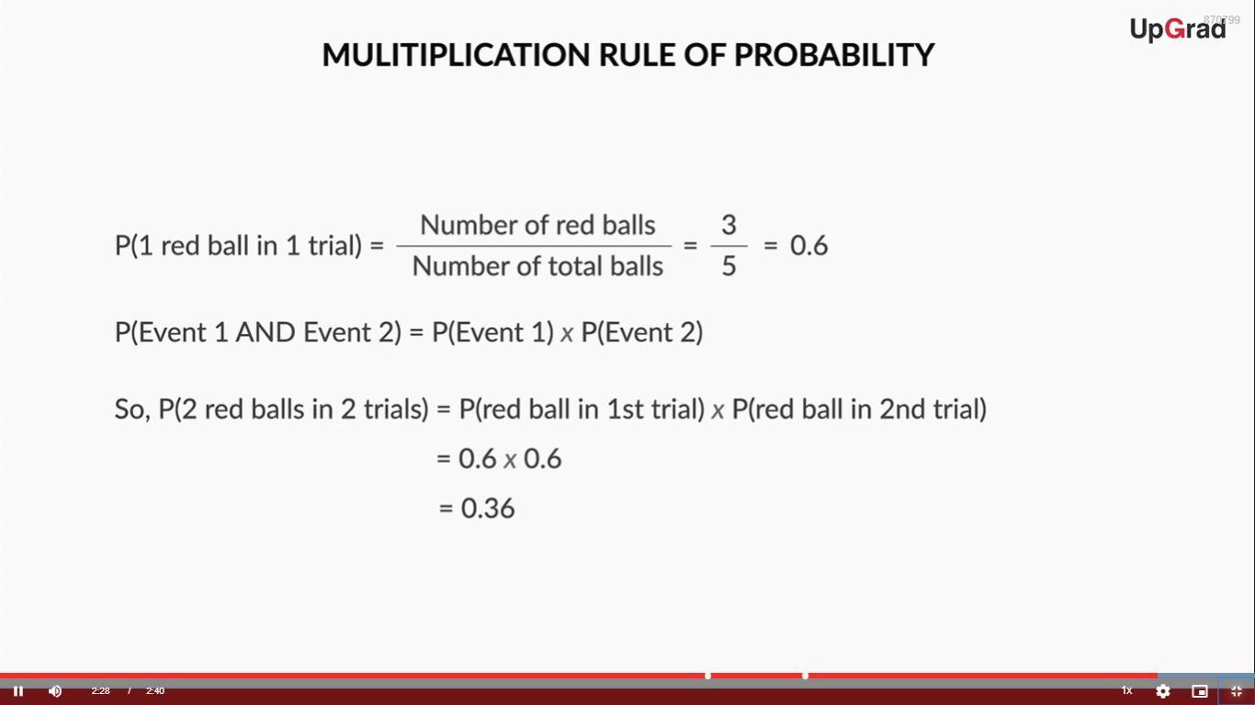
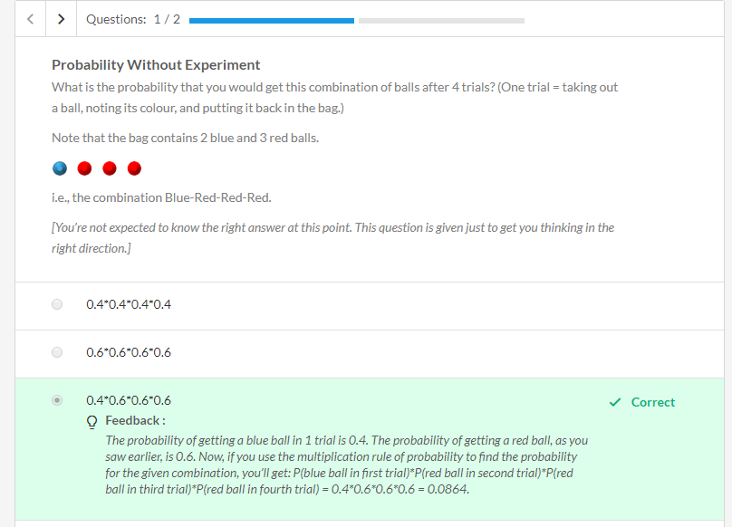
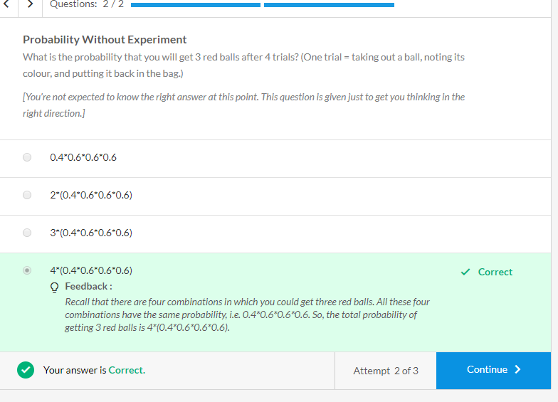
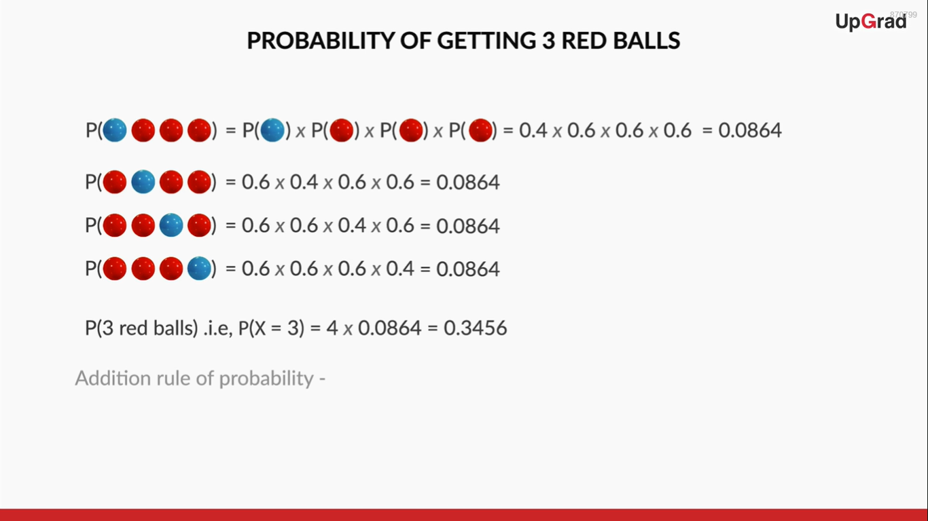
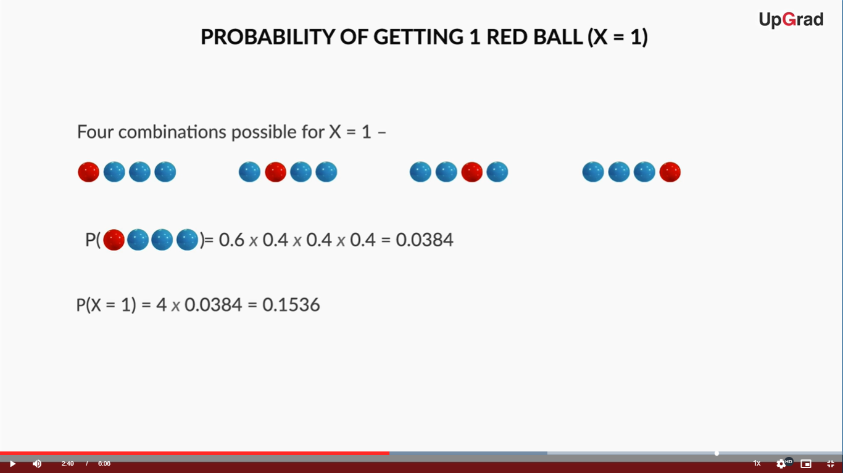
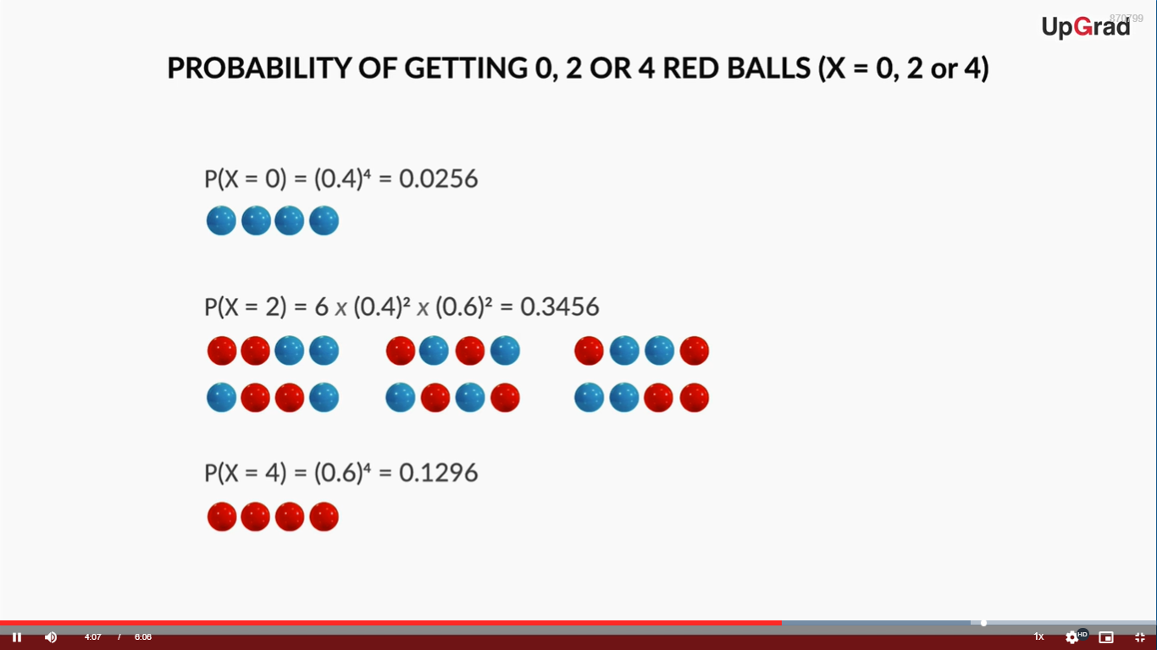
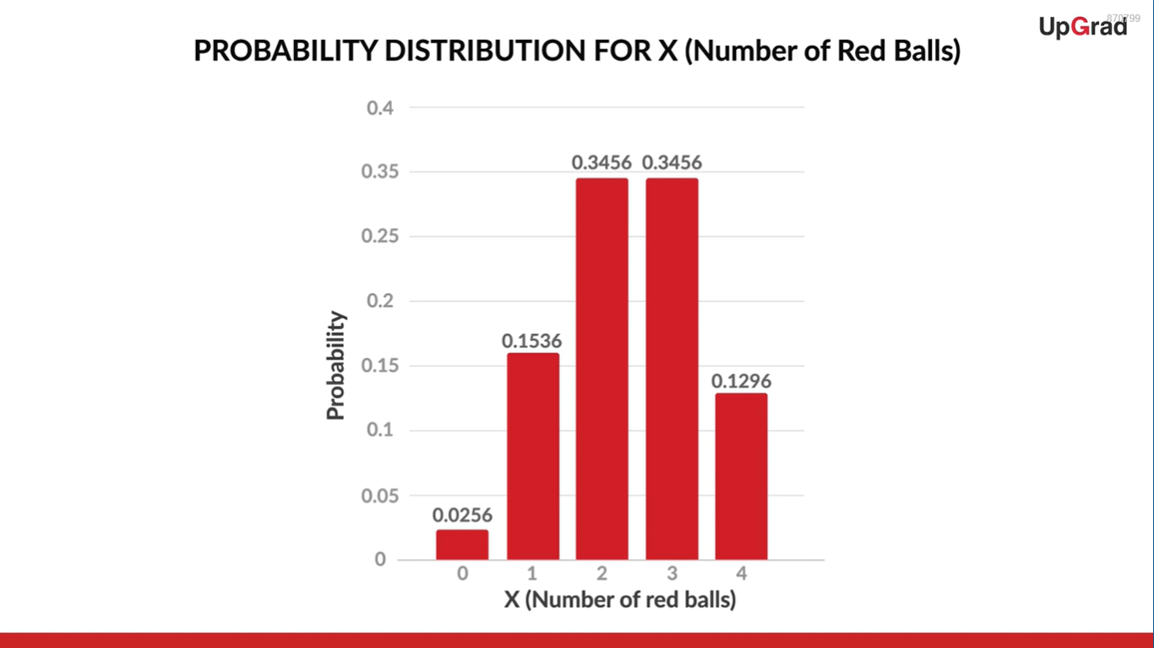
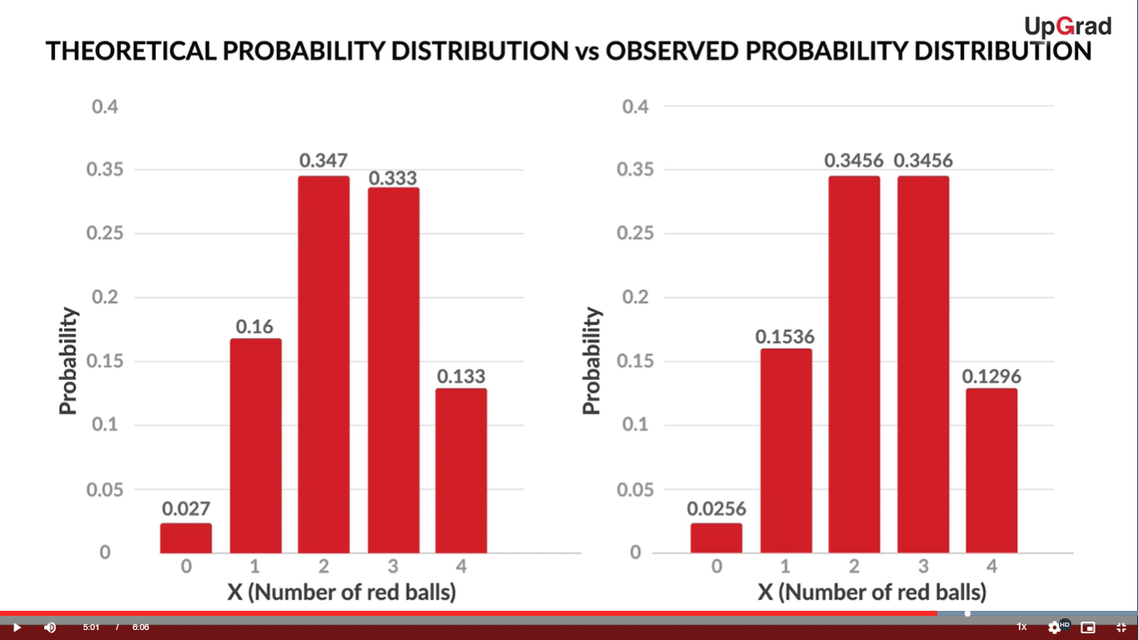
The distribution is not exactly the same, as the number of experiments done is very small (75). Had we done a lot more experiments, i.e., played a lot more games, we would have got an even closer estimate.

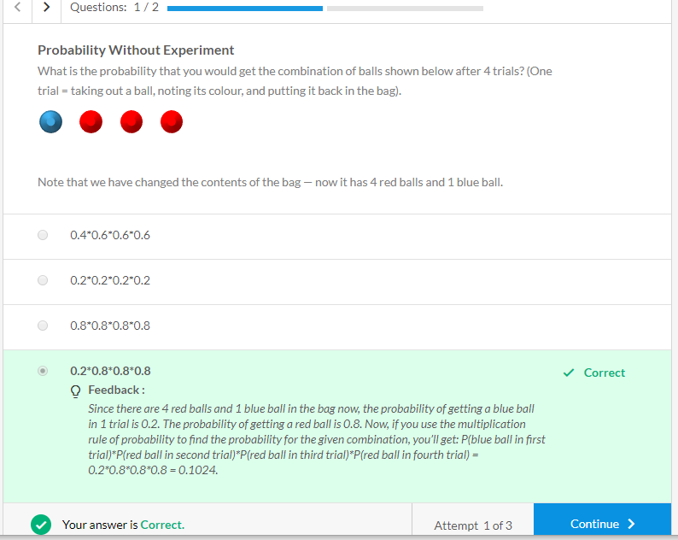
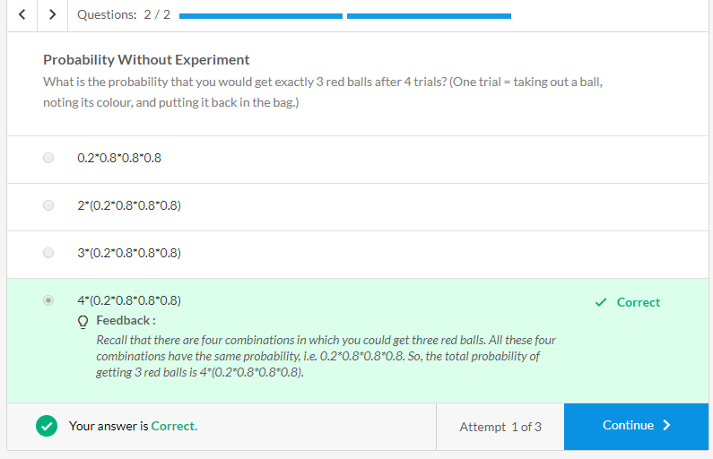

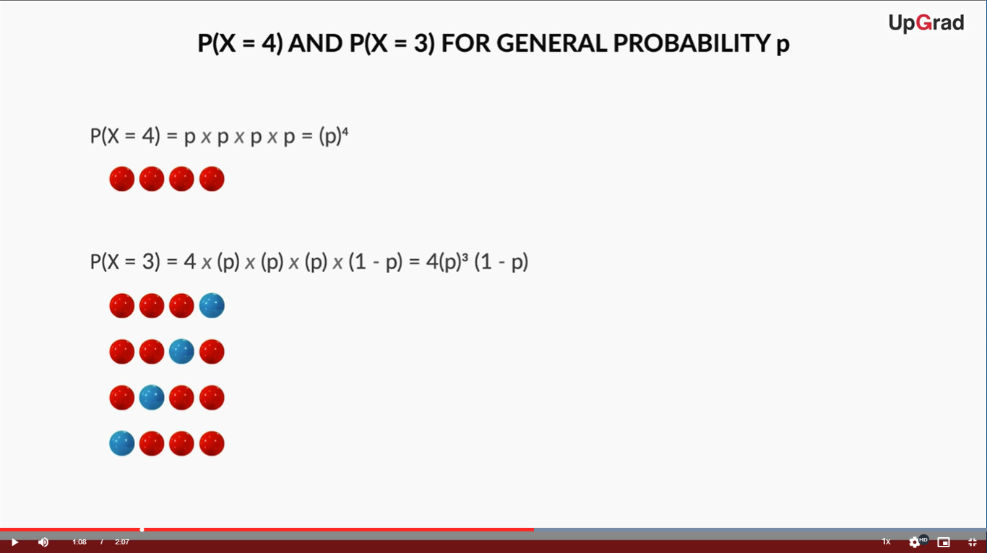
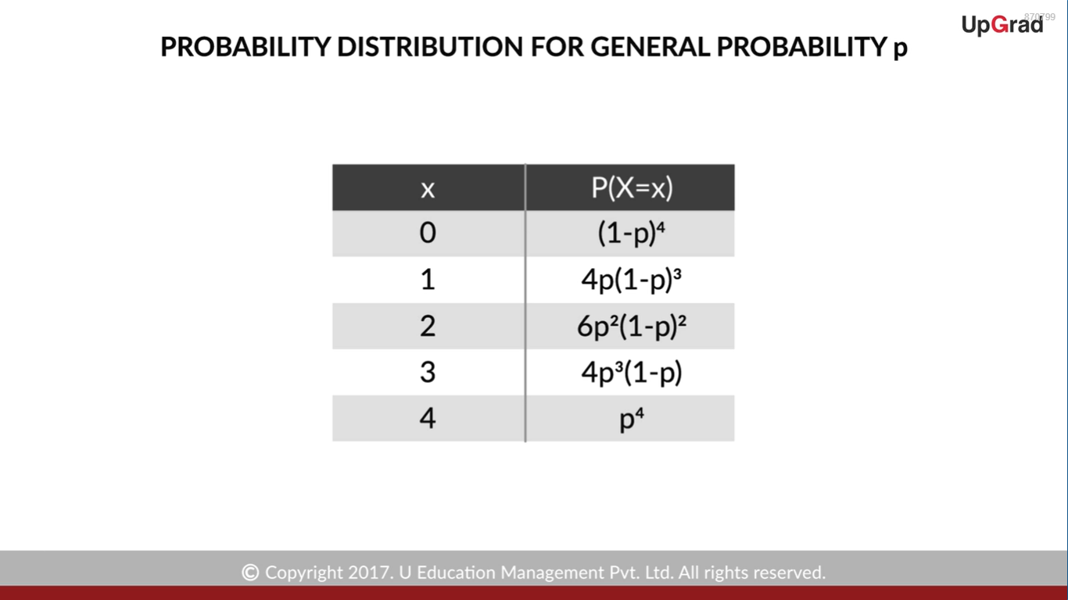

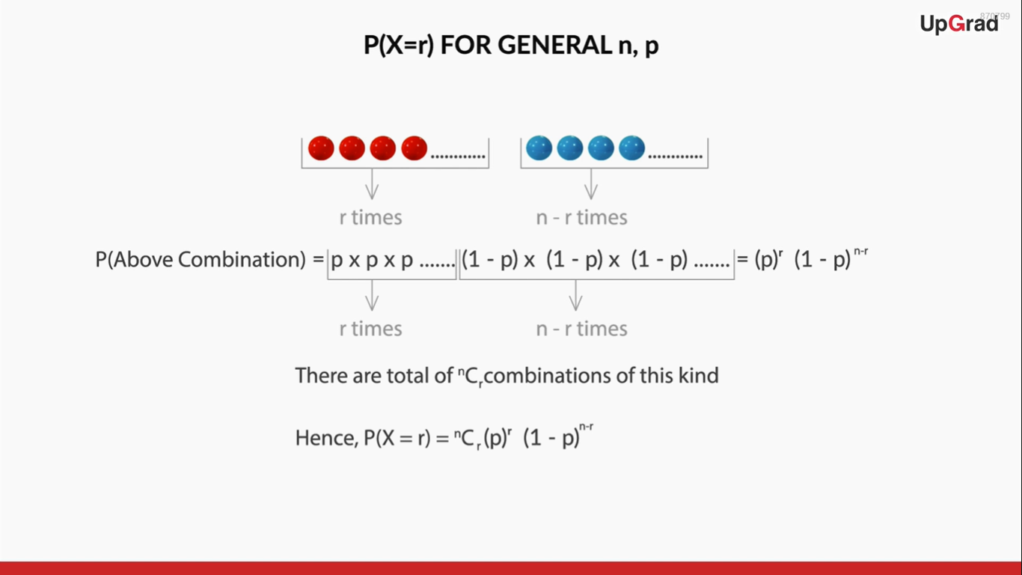
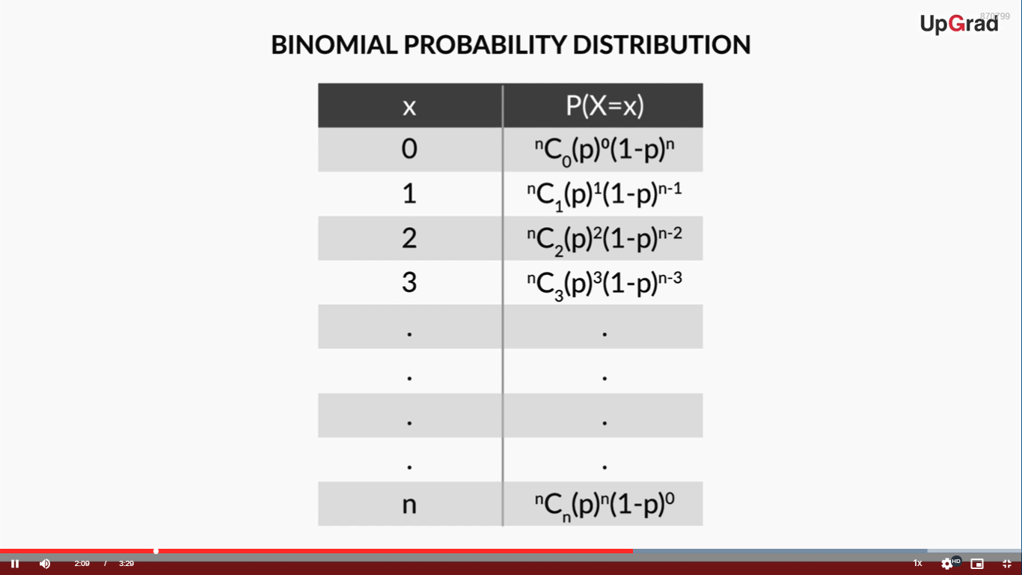
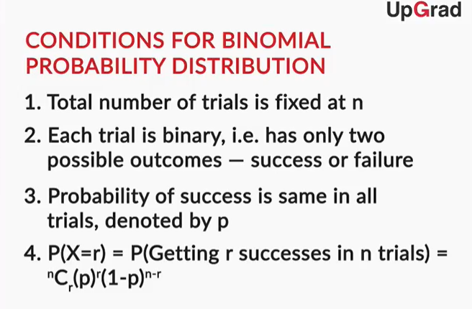
So, the formula for finding binomial probability is given by -

P(X=r)= nCr(p)r(1−p)n−r

Where n is no. of trials, p is probability of success and r is no. of successes after n trials.

However, as Prof. Tricha said, there are some conditions that need to be followed in order for us to be able to apply the formula.
- Total number of trials is fixed at n
- Each trial is binary, i.e., has only two possible outcomes - success or failure
- Probability of success is same in all trials, denoted by p

Binomial Distribution (Examples)
In the previous section, we listed down some conditions that are to be fulfilled for the binomial distribution to be applicable. Let’s take a few examples to understand these conditions in detail.

Binomial Distribution Applicable | Binomial Distribution Not Applicable
Tossing a coin 20 times to see how many tails occur | Tossing a coin until a heads occurs
Asking 200 randomly selected people if they are older than 21 or not | Asking 200 randomly selected people how old they are
Drawing 4 red balls from a bag, putting each ball back after drawing it | Drawing 4 red balls from a bag, not putting each ball back after drawing it

If you toss a coin 20 times to see how many tails occur, you are following all the conditions required for a binomial distribution. The total number of trials is fixed (20), and you can only have two outcomes, i.e. a tails or a heads. The probability of getting a tails is equal to 0.5 each time you toss the coin.

In a way, this is similar to drawing 20 balls out of a bag, replacing each ball after drawing it, and seeing how many of the balls are red. Here, the probability of getting a red ball in one trial is 0.5.

When you toss a coin until a heads occurs, the total number of trials is not fixed. This is similar to taking out balls from the bag repeatedly until you draw a red ball. You can still find the probability of getting a heads in 1 trial, in 2 trials, in 3 trials etc. and so on, but you cannot use binomial distribution to find that probability.

In the second example, where binomial distribution is not applicable, the experiment does not have only two outcomes, but many. It is similar to taking out balls from a bag that contains red, blue, black, orange, and other colours of balls. The probability distribution for this experiment cannot be made using binomial distribution.
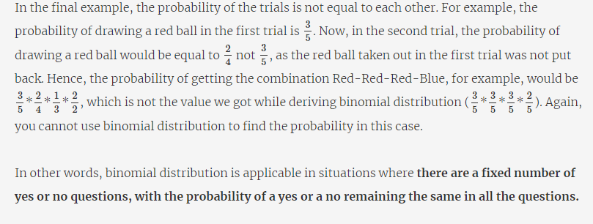
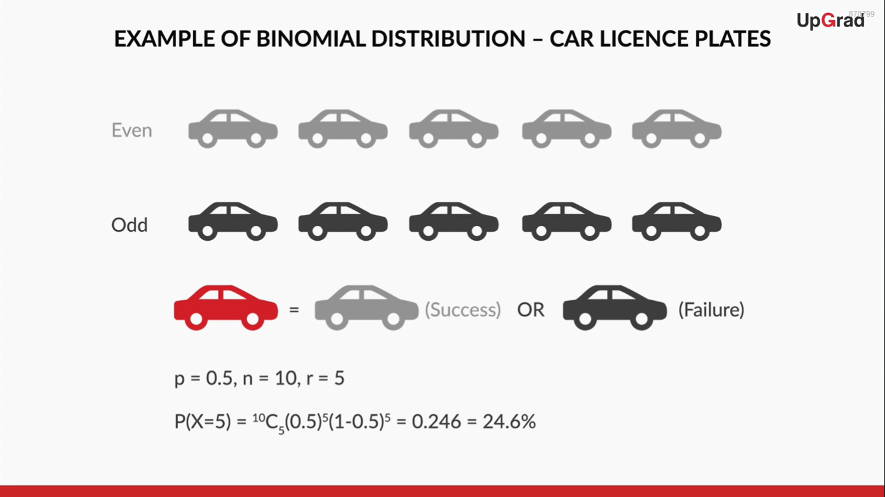
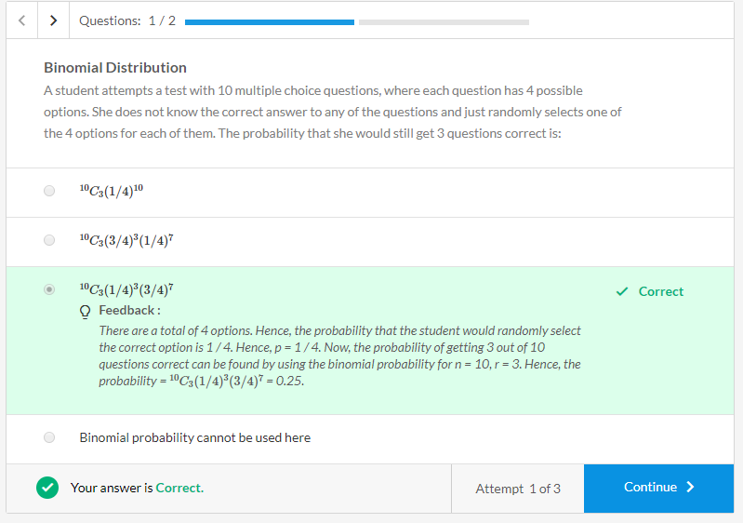
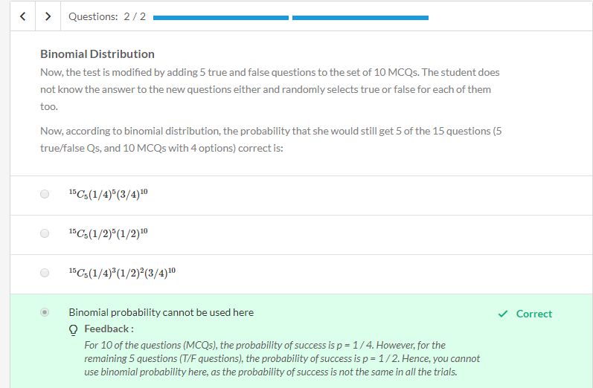

Cumulative Probability
In the previous example, we only discussed the probability of getting an exact value. For example, we know the probability of X = 4 (4 red balls). But what if the house wants to know the probability of getting < 3 red balls, as the house knows that for < 3 red balls, the players will lose and they will make money?

Sometimes, talking in less than is more useful, for example — how many employees can get to work in less than 40 minutes? Let’s explore how you can find the probability for such cases.

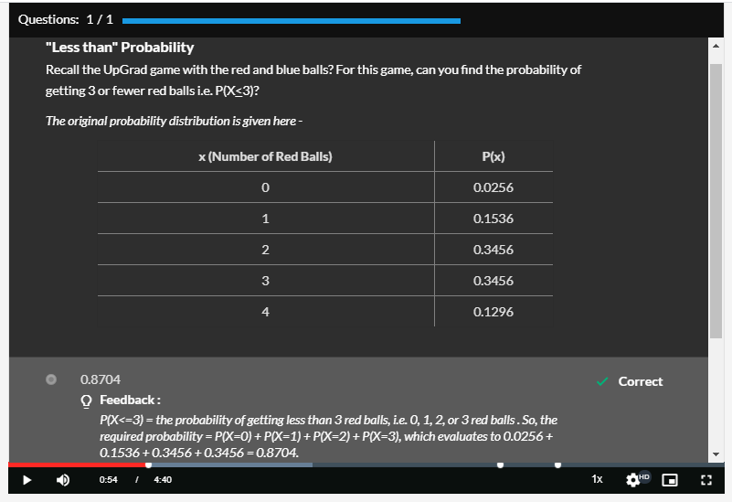


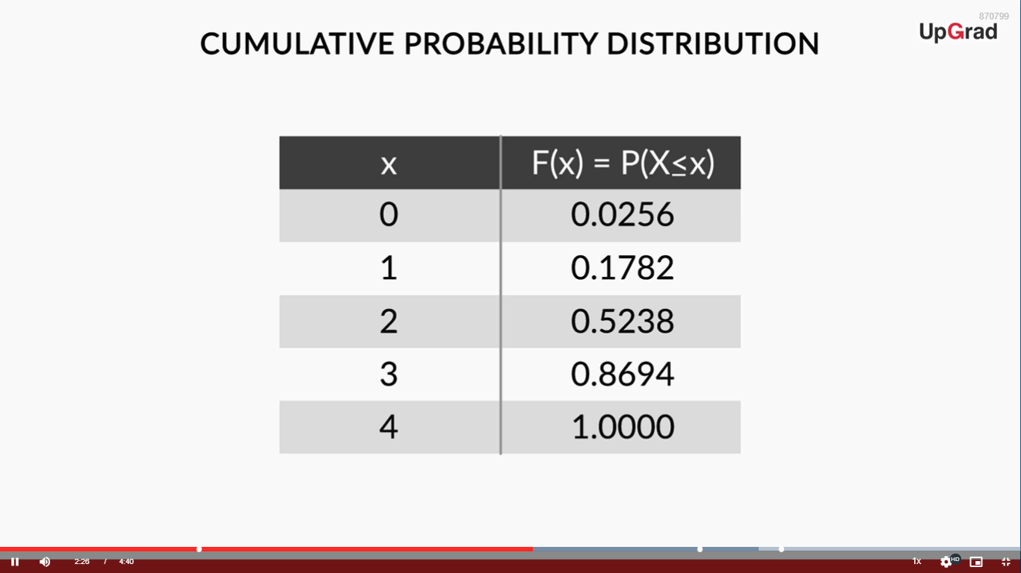
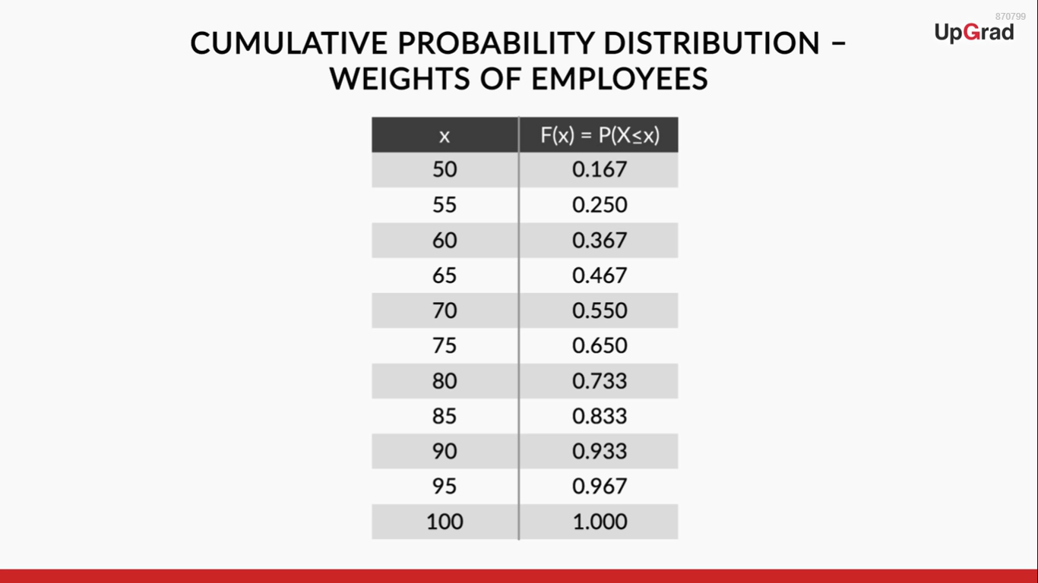
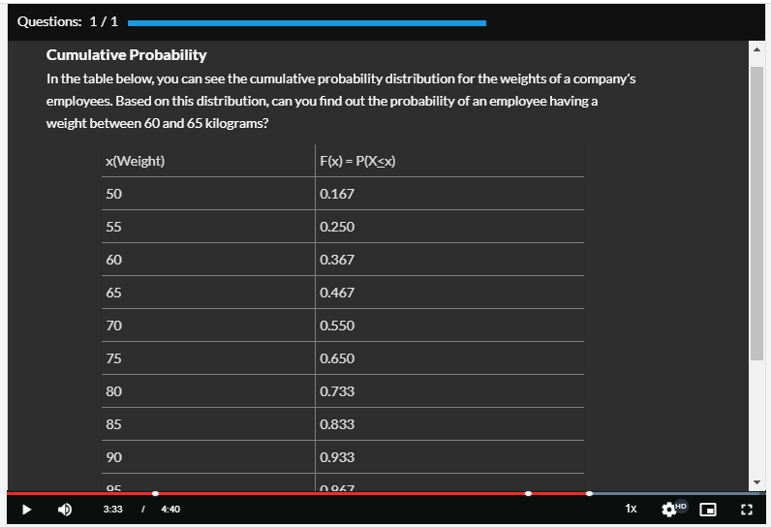

Clarification - The cumulative probability distribution table, shown in the above video (02:22 to 03:11) should be -
x | F(x) = P(X<x)
0 | 0.0256
1 | 0.1792
2 | 0.5248
3 | 0.8704
4 | 1.0000

So, the cumulative probability of X, denoted by F(x), is defined as the probability of the variable being less than or equal to x.

In mathematical terms, you would write cumulative probability F(x) = P(X<x). For example, F(4) = P(X<4), F(3) = P(X<3).

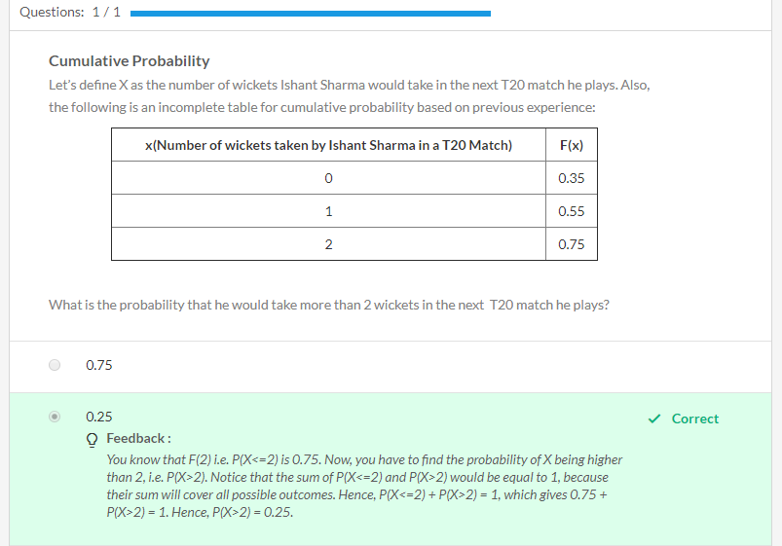

Practice Questions
These questions are NOT graded.

Let’s say you get a job as a senior analyst at a food regulatory body such as the FSSAI. One of your tasks is to check if the amount of lead content in certain food products is within the permissible limit.

Recently, the company Kwick Foods filed a complaint against Sunshine, its competitor, that Sunshine’s ready-to-cook pasta contains excess quantities of lead.
Suppose you take 10 random pasta packets from the market and get it tested for the amount of lead. It just so happens that you have picked out packets from a very defective batch, and there is a 5% probability that any pasta packet you select is going to be defective.
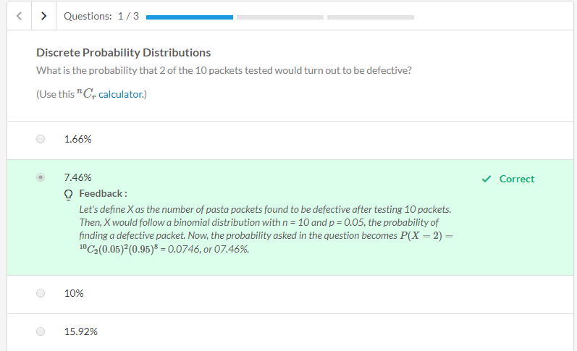
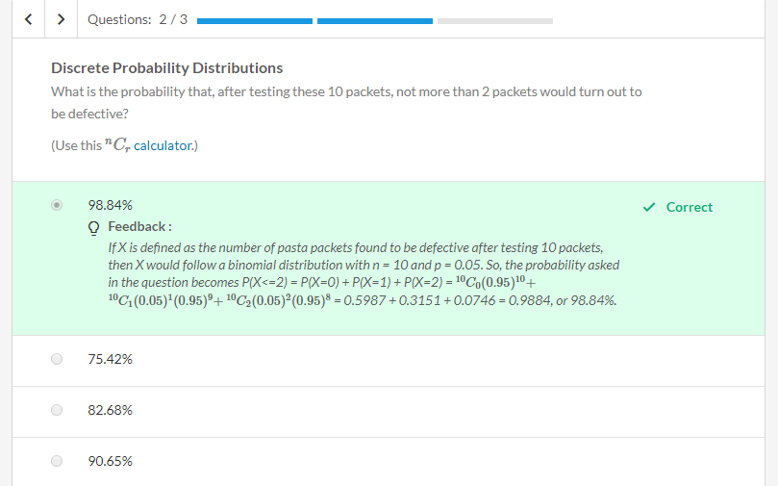
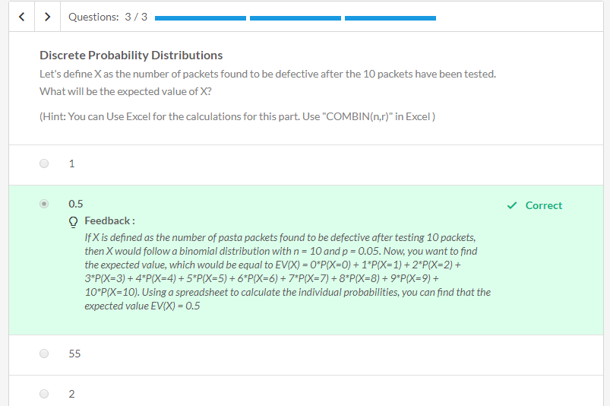

Graded Questions
Suppose a new cancer treatment has been discovered, claiming to increase the one year survival rate for pancreatic cancer to 40%. In other words, the probability that a patient suffering from pancreatic cancer would survive for at least one year after receiving this treatment is 40%.
Suppose a hospital is planning to use this treatment for its pancreatic cancer patients.
